The Lambert Medical Centre

Happy New Year from us all

January 2019 Newsletter

Staffing News

We have welcomed Dr Carol Adams to the surgery. Dr Adams is consulting 2 days per week.

Dr Hiles is planning to retire from the Practice in May 2019. Please be assured that if you usually see Dr Hiles, all the other Drs have access to your full medical record and will be pleased to see you.

FLU CLINICS

We still have flu vaccines available for all ages of patients.

If you haven’t had your flu vaccination, please contact Reception and book an appointment with a Nurse.

Ordering Repeat Medication

If you have medication on repeat the easiest and safest way to re-order using the on-line reordering facility through Patient Access. Patients that have used our auto re-order system or local pharmacy’s managed repeats systems are being asked to change to online ordering or to drop the repeat request in to the surgery or chemist. Our CCG, Hambleton, Richmondshire and Whitby CCG have requested this change for a number of reasons:

- To put you in control of your medication
- To address safety concerns as prescriptions may change from one order to the next and the automatic system might not pick this up.
- To reduce over ordering and medicines waste.

Ways to order your repeat medication:

- Ordering online
- Via repeat prescription box in the surgery
- Posting the repeat prescription to the practice

Patients who are unable to use any of the above methods should discuss this with the surgery dispensary or the chemist if you live in town, and you will be provided with additional support to ensure you are able to get your medication.
Self Care

NHS England have published guidance for conditions for which over the counter (OTC) items should not routinely be prescribed in primary care. It listed 35 conditions plus probiotics and vitamins and minerals, as areas where self-care may be more appropriate. These prescriptions include items for a condition:
- That is considered to be self-limiting and so does not need treatment as it will heal of its own accord;
- Which lends itself to self-care, i.e. that the person suffering does not normally need to seek medical care but may decide to seek help with symptom relief from a local pharmacy and use an over the counter medicine.
Or items:
- That can be purchased over the counter, sometimes at a lower cost than that which would be incurred by the NHS;
- For which there is little evidence of clinical effectiveness but are high cost to the NHS, such as vitamins / minerals and probiotics.

The document sets out guidance Primary Care on over the counter (OTC) products for 35 minor and/or self-limiting conditions. The guidance is intended to encourage people to self-care for minor and self-treatable conditions only, rather than for items prescribed to treat long-term conditions and associated symptoms.
If you require more information please ask your GP or the Dispensary.

Did Not Attends

We review and record the number of wasted appointments we have each month. The reason we do this is to highlight the problem and to hopefully encourage people to cancel ‘not needed’ appointments so that they can be used for someone else.
We have a Missed Appointment Policy which states that if someone misses 3 or more appointments in any 6 month period we will contact them and they may be advised that they are not able to pre-book appointments. If Patients continue to abuse the appointment booking process they may be asked to register elsewhere.

To help patients remember their appointment we are able to print off the details when it is made in the surgery and we also offer a text reminder service for those patients who have provided us with an up to date mobile number.
If you no longer need an appointment you can cancel by ringing the surgery or by replying ‘cancel’ to your text reminder. If you have booked your appointment using our online booking service, you can also cancel via the online booking facility.

Park Run Practice
GP practices are encouraged to develop closer links with their local parkrun to become certified ‘parkrun practices’, with health care practitioners signposting patients and carers to parkrun, particularly those who are the least active and have long-term health conditions. We are a Parkrun practice.
On Saturday 20th October staff and patients took part and volunteered at Northallerton Parkrun.

For some, this was their first Parkrun and they have continued to enjoy running and as a Practice we are all keen to support the Parkrun again.
Parkrun is open to all, including those who are inactive or have health conditions or disabilities, whether people want to improve their fitness, make new friends, cope with health problems, learn new skills or simply be outside with others, parkrun has a positive impact on health and wellbeing and changes lives.
If you want details of local parkruns please ask at reception or look on the website www.parkrun.org.uk
Christmas Collection

This year, staff at the surgery donated food and provisions for Thirsk Clock Foodbank instead of sending Christmas Cards.

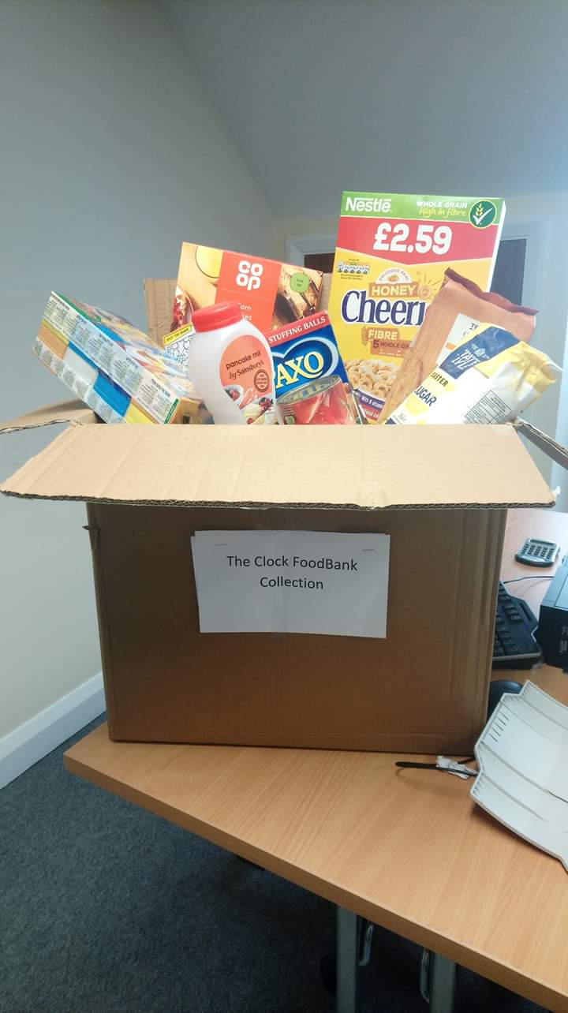

The Lambert Medical Centre
We are now active on social media. Follow us on Twitter and Facebook where we post details about local and national health campaigns.
@lambertmedical1
@lambertmedicalcentre

Online Access
Please remember, you can book GP appointments, order repeat prescriptions and view your summary care record online now through our website. This is a convenient and safe way to access these services and we encourage all patients to use this facility.
The process to order repeat medicines on-line is simple and secure, enabling you to select and request only the items you require directly from the practice. You can check your current stock levels of medicines (both regular and as required items) in your home prior to submitting your order, then can avoid over-ordering or ordering ‘just in case’. It also allows you to order at a time convenient for you, including outside regular opening times.
If you are not already registered for online services just call in at the surgery with some form of ID and a member of staff can give you your unique login details. www.lambertmedicalcentre.co.uk
Don’t forget we have a Patient Participation Group:
PPGs are groups of active volunteer patients that work in partnership with practice staff and GPs – this unique partnership between patients and their practices is essential to achieving high quality and responsive care.
The group can help the practice by enabling us to be more proactive in providing the services that truly reflect what patients want and need.
We tend to communicate via email and meet up face to face just a couple of times a year so the commitment isn’t too onerous. We aim to have an inclusive and representative membership so…..

Please see our website for details on how to join
www.lambertmedicalcentre.co.uk

