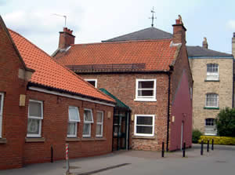 The Lambert Medical Centre
Happy New Year

January 2020
The staff at the Lambert Medical Centre chose to donate to the local food bank rather than send Christmas Cards to each other. We managed to collect all this food which was delivered to Thirsk Clock before Christmas.

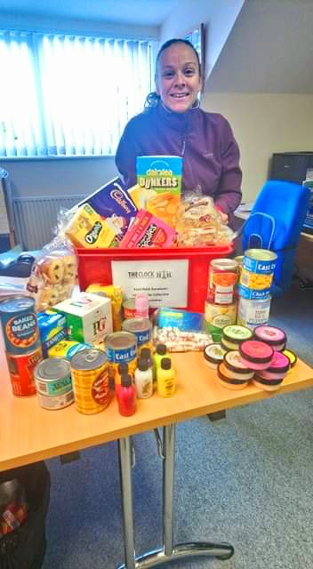

Flu
Influenza is a virus that infects many people each year, causing severe illness and sometimes death. The flu vaccination is the best possible protection against this unpredictable virus.
We still have vaccines available so if you are eligible and have not already, please book in for your free flu vaccination here at the surgery

Who is eligible to have the flu vaccine? Patients who:
- are 65 years old or over
- are pregnant
- have certain medical conditions
- are living in a long-stay residential care home or another long-stay care facility
- receive a carer's allowance, or you're the main carer for an elderly or disabled person whose welfare may be at risk if you fall ill

Why have your vaccinations at YOUR GP Surgery?

- We offer a setting where we can check your medical records and make sure you get the most suitable vaccine
- We can offer protection for those who may be forgetful by reducing the risk of duplication in vaccines being administered
- We offer a fast, efficient and friendly flu clinic service with your local surgery team
- We can ensure continuity of care for our patients and carers (we know you already)
We order flu vaccination for all eligible patients registered with us. We have to do this and assure NHS England we have enough vaccines for everyone. We have to buy the vaccines for you and we can only return limited numbers that go unused, and the rest have to be paid for by the surgery.

Please book your appointment to receive your vaccination at Lambert Medical Centre, we have bought your vaccine and want to protect you!

E-Consultations

Pressures on Primary Care are increasing and we need to explore new ways of working to help us and help patients. Online consultations are a way for patients to contact their GP practice without having to wait on the phone or take time out to come into the practice. Using a smartphone, tablet or computer, you can contact your practice about a new problem or an ongoing issue.
Any registered patient will be able to access the service.
You can chose to consult with a GP about a non-urgent medical problem, send a message about an administrative task or explore self-help resources.
If you are wishing to consult about a medical problem, you will be asked a series of questions about your symptoms which then generates a report which is sent to a clinician who then can chose the best course of action: to refer, prescribe, phone with advice, see you or direct you to the most appropriate service.

Car Parking at the surgery

You may have noticed if you have been to the surgery lately that work has started on the Lambert Hospital Site next door. The hospital side of the carpark (left as you enter) has been used by patients coming to the surgery as well as visitors to Thirsk, shoppers and local residents whilst the Hospital has been closed and as this is now cordoned off, parking is at a premium as there is only the surgery side available.
The car park is private and belongs to the surgery and should only be used by staff and patients whilst attending for appointments.

Texting

We are using a new texting service which allows individualised texts to be sent to patients.
The type of things we might text you about:
- let you know that your test results are clear
- let you know your results are back and we would like to speak to you
- ask you to contact the surgery to make an appointment
- confirming that your referral has been done
- advising you that your medication is now ready for collection
- you are due your routine screening
- your regular chronic disease check-up is due

We hope patients will find this a convenient and effective way of communicating.
If you are not happy to receive these texts, please let the surgery team know and we can remove you from this service.
Please be mindful that it is your responsibility to advise the surgery if you change your mobile number.

Dispensary phone lines

Please be aware that from January 2020, the Dispensary phone line will operate only between the hours of 11am and 3pm.
This will allow the Dispensary staff to concentrate on their dispensing duties at the times when the surgery is most busy.
We do not take requests for prescriptions over the telephone. These requests should be made either by using the online services, or by placing your request slip in the box in Reception.

Parkrun

The Lambert Medical Centre is a Parkrun Practice
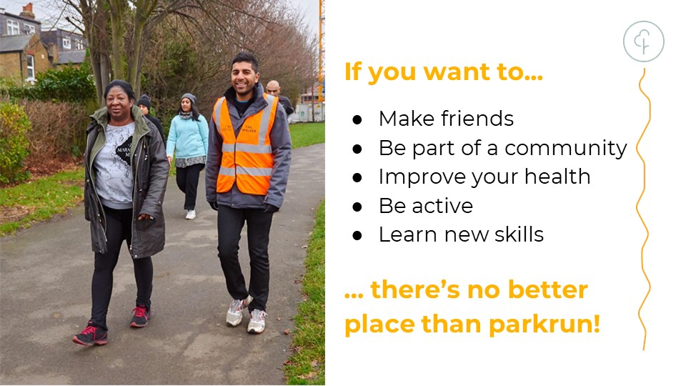
We support Parkrun to support the health and wellbeing of our staff and patients
On Saturday 25th April we will be having a Parkrun Takeover at Northallerton.
It would be great if you could join us…you can either run, walk volunteer or just support.
The event starts at 9am at Hambleton Leisure Centre.
Please ask at Reception for details or look at the Parkrun website:
https://www.parkrun.org.uk/northallerton

NHS APP

The new, simple and secure way to access a range of NHS services on your smartphone or tablet.

Use the NHS App to:
- check your symptoms
- find out what to do when you need help urgently
- book and manage appointments at your GP surgery
- order repeat prescriptions
- view your GP medical record securely
- register to be an organ donor
- choose how the NHS uses your data

The Lambert Medical Centre
We are now active on social media. Follow us on Twitter and Facebook where we post details about local and national health campaigns.
@lambertmedical1 @lambertmedicalcentre

Don’t forget we have a Patient Participation Group:
PPGs are groups of active volunteer patients that work in partnership with practice staff and GPs – this unique partnership between patients and their practices is essential to achieving high quality and responsive care.
The group can help the practice by enabling us to be more proactive in providing the services that truly reflect what patients want and need.
We tend to communicate via email and meet up face to face just a couple of times a year so the commitment isn’t too onerous. We aim to have an inclusive and representative membership so…..
Please see our website for details on how to join
www.lambertmedicalcentre.co.uk

