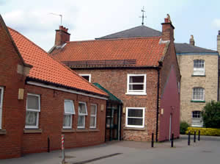 The Lambert Medical Centre

October 2020

Welcome to the Lambert Medical Centre Newsletter.
2020 will certainly be a year we won’t forget.

Throughout the COVID-19 pandemic, we have remained open to patients. We have offered appointments using new ways of working and new technology. We have worked hard to make sure we remained available to speak to, and to offer appointments to anyone who needed them.
While we appreciate that patients sometimes prefer to see a GP face to face, there are reasons why we have offered additional online or telephone consultations, and government guidance has played a big part in this. It has remained the case that if we have needed to see a patient face to face, or felt it was important for their care, we have asked those patients to come in to see us.

Offering new ways of working has helped some patients to access appointments they wouldn’t normally have been able to attend due to their commitments, such as their work or caring responsibilities.

It remains the case that bringing patients into the surgery while coronavirus is with us presents some significant challenges. We want to explain more about these challenges.

We always pay close attention to the cleaning of our premises. However, the level of cleaning required between patients during the pandemic means that if all our patients were to come into the surgery, we would not be able to offer the same number of appointments because of the increased cleaning time that would be needed.

Additionally, changing PPE (Personal Protective Equipment) between each patient adds additional time to the end of each appointment. The difficulty in obtaining PPE has also meant that we have needed to be more cautious about the way we use scare resources.

Another challenge we face is how to make sure that social distancing is as good as it possibly can be, and that we maintain a ‘COVID-secure’ environment. Some of the things we need to take into account when considering this are: the number of people in the waiting room, the number of people who cross in the corridors, and the toilet facilities that are available.

As caring employers, we need to ensure that we keep our staff safe as well. Our staff are people too, and some may have ethnicity or health issues that make them more vulnerable to the effects of COVID-19.

Finally, and we think most importantly, we need to consider you, our patients. We have many elderly and vulnerable patients with health conditions that make them more vulnerable to COVID-19 than most. We also know that there are young and healthy people who have been seriously affected by COVID, so it isn’t just the elderly or infirm we need to protect.

Increasing the number of patients in the surgery means that we increase the risk for everyone – particularly if some of those people have symptoms of COVID-19 and are unwell enough to need to be seen.

As doctors and staff working in GP practices, we really want to do the best we can for our patients. We do the jobs we do because we care about the people we look after.

We would all love to see a return to ‘normal’ life and the easy face-to-face care we have always provided, but at the moment offering fewer face-to-face appointments keeps patients safe and provides the maximum number of appointments we can.

As always, we are available to talk to patients, and we want to hear from those who need us. While we understand patients’ frustrations with the current situation, we hope that you will continue to help and support us, as you have always supported the NHS, so that we can go on providing you with care and support in the coming weeks and months.

FLU Season

We are now in the midst of Flu season and we felt it might be a good time to explain some of the challenges we are facing this year.

We have to order our flu vaccines a year in advance so our flu vaccinations were ordered in September last year. We ordered enough to vaccinate patients that were eligible based on numbers who would normally take up the offer.
We pay for these vaccines and if we don’t use the vaccine by the end of February, we have to throw them away. There are two different types of vaccine. One recommended for people aged 65 and over and one for people under 65. These vaccines come from different manufacturers and are delivered at different times.

The number of people who want a flu vaccine this year has far exceeded the numbers we would usually expect, especially in the patient group aged 65 and over. At the moment we have no more stock of this vaccine following our 3 Saturday clinics and week day clinics.

We have just been informed that we will be able to order more vaccines but we don’t yet have a precise delivery date – but have been advised that it will be sometime in November.
If you are aged 65 or over and would like a flu vaccine please let us know and we will then contact you if we are allocated further stocks.
If you are under 65 and have a chronic condition which makes you eligible for a flu vaccine, you should have received an invitation from the surgery. Please contact us as soon as possible to make your appointment.

This year, the Government announced that vaccines will be available for ‘extra’ groups of patients including those aged between 50 and 64 with no chronic condition. This is information we have been asked to share:

People in this age group will not be vaccinated until November and December, providing there is sufficient vaccine, and no appointments will be offered for this age group until then. This is to ensure that those who are most at risk are vaccinated first.

Building work
Our building alterations were due to start in March but were postponed during lockdown. We resumed as soon as we could and Phase 1 which included converting 1st floor living accommodation to office space, is now complete. Our Reception and Admin Team are now working from these new rooms.
We are also creating a new purpose built Dispensary Area and also installing a lift to allow us to create additional consulting rooms on the first floor.

All of this work will provide us with additional work space helping us continue to provide healthcare to our growing practice population.

We apologise for any inconvenience and noise whilst we carry out these works.
We are all very excited to see the project completed which we hope will be by Christmas.

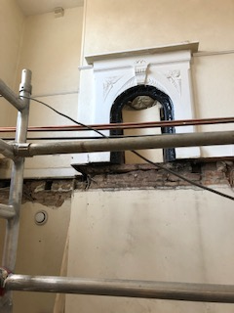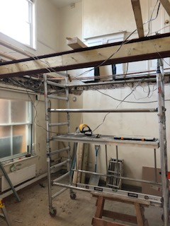

Online Consultations – available via our website.

If you are struggling to get through on the phone lines or have a problem that is not urgent please try Online Consultations. Online consultations are a way for patients to contact their GP practice without having to wait on the phone or take time out to come into the practice. Using a smartphone, tablet or computer, you can contact your practice about a new problem or an ongoing issue.
Any registered patient is able to access the service via www.lambertmedicalcentre.co.uk
You can chose to consult with a GP about a non-urgent medical problem, send a message about an administrative task or explore self-help resources.
If you have a medical problem, you will be asked a couple of questions about your symptoms; this is then forwarded to a clinician who will decide the best course of action: to refer, prescribe, phone with advice, see you or direct you to the most appropriate service.

Dispensary phone lines

Please be aware that the Dispensary phone line is open from 11am to 3pm every week day.
This is to allow the Dispensary staff to concentrate on their dispensing duties at the times when the surgery is most busy.
We do not take requests for prescriptions over the telephone.
These requests should be made either by using the online services, or by placing your request slip in the box in Reception.
The Lambert Medical Centre
We are active on social media. Follow us on Twitter and Facebook where we post details about local and national health campaigns.
@lambertmedical1 @lambertmedicalcentre
Don’t forget we have a Patient Participation Group:
PPGs are groups of active volunteer patients that work in partnership with practice staff and GPs – this unique partnership between patients and their practices is essential to achieving high quality and responsive care.
The group can help the practice by enabling us to be more proactive in providing the services that truly reflect what patients want and need.
We tend to communicate via email and meet up face to face just a couple of times a year so the commitment isn’t too onerous. We aim to have an inclusive and representative membership so…..

Please see our website for details on how to join
www.lambertmedicalcentre.co.uk

