Mental Health Awareness Week – Monday 9 - May 2022 – Theme - Loneliness
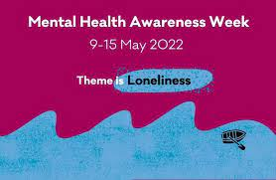

Mental Health Awareness week will explore the experience of loneliness, its effect on our mental health and how we can all play a part in reducing loneliness in our communities.
NHS Feeling Lonely ? Most people feel lonely sometimes, for many different reasons. If loneliness is affecting your life, there are things you can try that may help.
Support is also available if you're finding it hard to cope with stress, anxiety or depression.
If you're not sure how you feel, try our mood self-assessment - Depression and anxiety self-assessment quiz - NHS (www.nhs.uk)

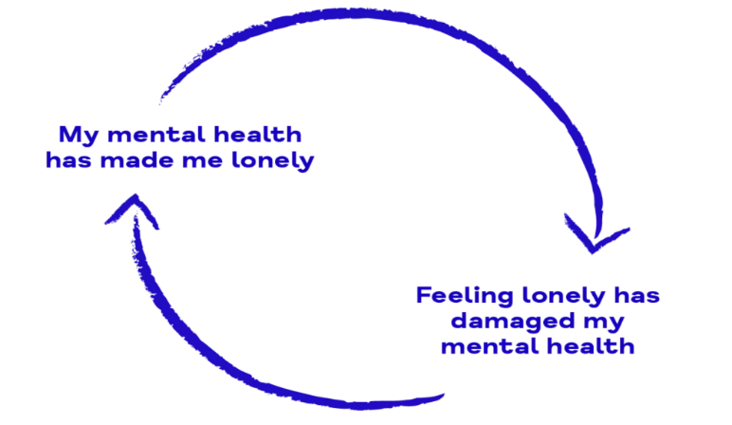
What is loneliness?
“Loneliness occurs when there is a gap between our actual and desired social relationships, and when the quality or quantity of these relationships does not meet our expectations.”

Loneliness is the state discomfort that results when one perceives a gap between one’s desires for social connection and actual experiences of it. https://www.psychologytoday.

In total, 45% of adults feel occasionally, sometimes, or often lonely in England. This equates to twenty-five million people.
The facts on loneliness | Campaign to End Loneliness

Suggested Provisions / Resources
Living well North Yorkshire –  1:1 Support to reduce isolation  Areas covered –  Harrogate / Craven  Hambleton / Richmondshire  Scarborough / Whitby / Ryedale  Selby | Partners Information Pack including referral process. Eligibility 18 +  Living Well - Information Pack | North Yorkshire County Council
NHS – Every Mind Matters | This website has information and resources on :  - Feeling lonely  - Advice for loneliness  - Support for loneliness  - Find more support  www.nhs.uk/every-mind-matters/lifes-challenges/loneliness/
MentalHealth.org.uk | Provide help and advice on how to cope with loneliness and improve your mental health.  www.mentalhealth.org.uk/campaigns/mental-health-awareness-week/loneliness-help-and-advice
Marmalade Trust is the UK’s leading loneliness charity for all ages and the only charity in the world specifically dedicated to raising awareness of loneliness.  Areas covered – National | Guides to Loneliness  ABOUT LONELINESS | Marmalade Trust
MIND have some brilliant resources and information to tackle loneliness including  Areas covered – National | About loneliness - About loneliness | Mind, the mental health charity - help for mental health problems  How can I manage loneliness? Tips to manage loneliness | Mind, the mental health charity - help for mental health problems
Age UK  Areas covered – National.  Local link covers  Northallerton  Richmond  Harrogate  Ripon  Skipton  Darlington | Age UK North Yorkshire & Darlington offers a range of quality support services for people aged 50+. Including befriending  Age UK North Yorkshire & Darlington | Our Services
Learning – Attending training can reduce isolation and develop peer support  Areas covered – North Yorks | NYCC Adult education and Training offer several courses – eligibility 19 +  Adult education and training courses | North Yorkshire County Council
Online | British Red Cross – run FREE online courses  Tackling loneliness (Zoom) - (I hour 30mins)  This interactive video workshop includes activities and group discussions to explore the causes and effects of loneliness, where you will have the opportunity to reflect and share your own personal experiences. Taking place online via Zoom, you will need access to a camera and microphone to take part.  Exploring loneliness openly (phone) – 1 hour  This is an interactive phone workshop where you will have the opportunity to speak openly about how it may feel to be lonely or isolated and learn skills to help others who may be struggling. Taking place over the telephone, all attendees will be expected to participate in group. Please ensure you have access to a microphone.  Book adult individual online workshops (19+) (office365.com)
Apps - Technology can play a significant role in reducing loneliness. | 7 apps for loneliness  7 Different Apps For Loneliness | Holland & Barrett (hollandandbarrett.com)
Technology | Facetime, Skype, WhatsApp and a host of other messaging platforms offer ways to stay connected to those close to our hearts, even if you live far away from each other. Video chats and instant messaging allow us to keep in touch with anyone, so use it to maintain and nurture connections.
U3A  u3a is a UK-wide collection of 1000+ locally run interest groups that provide opportunities for those no longer in full-time work (retired) to come together and learn for fun.  Areas covered – National. | Find your local group on the link - u3a - Home
Pursue hobbies and interests | Pursuing hobbies and interests is one of the best ways to develop relationships and get out of the trap that is loneliness. Think about what you enjoy doing or what you would like to try. For example, you could volunteer, get involved in your local community, try an exercise class, join the gym or take up cookery. If you’re struggling for inspiration, why not think about what you used to enjoy as a child?  Joining a sports team can give us a hobby, creates an immediate group of people we regularly see, and grows a sense of belonging. There are thousands of teams in hundreds of sports to join, so find one that works for you.
Youth Loneliness  Research conducted by The Co-op Foundation suggests that 76% of young people felt lonely at least occasionally during the lockdown, compared to 59% before restrictions began | Community First Yorkshire have developed several resources to download  A series of 4 posters highlighting some of the issues around loneliness:  - Poster 1 for young people who feel different at school.  - Poster 2 for young people who don’t feel they fit in.  - Poster 3 for young carers.  - Poster 4 for young people with a disability.  An accompanying flyer with information about loneliness and signposts young people to The Go-To.  A resource pack for professionals, providing more detailed information, links to further resources and an example lesson plan.

