**The Lambert Medical Centre**

2 Chapel Street, Thirsk, YO7 1LU

Tel No. 01845 523157

**New Patient Questionnaire**

**About You**

Title: ______ Forename(s): ____________________ Surname: ___________________

Date of Birth: _________________ Previous Surname: _________________

Email Address: ________________________________

**Residency**

Do you live in a residential/ Nursing Home Yes  No

Do you have a door access key code you would like to keep on record: _______________

**Contacting You**

We will use your contact details to send reminders about appointments, reviews and other services we offer that may be of benefit in your medical care e.g. flu clinics

Do you consent to the surgery sending text messages to your mobile Yes  No

Do you consent to the surgery sending messages to you by email? Yes  No

**Next of Kin (for Emergency Contact)**

Name: __________________________________

Relationship to You: _______________________

Contact Number: __________________________  
Please ask the Receptionist if you would like a consent form to allow your Next of Kin to discuss aspects of your medical records.

**Ethnicity**

Having information about patients' ethnic groups would be helpful for the NHS so that it can plan and provide culturally appropriate services to meet patients needs. If you do not wish to provide this information, please indicate that below. Please indicate your ethnic origin by ticking the box below:

White British  Mixed British  Irish

Bangladeshi  African  Other  Please state:

Chinese  Caribbean  Indian

Pakistani  Prefer not to say

What is your main Language:

**Service Members**

As a practice we fully support the Armed Forces Covenant. We can only do this if we know our patient connections to the Armed Forces

Please tick the boxes that apply to you:

I AM a Military Veteran

I AM currently serving in the Reserve Forces

I AM a family member of a veteran or someone currently serving

**Carer Status**

Are you a carer? Yes  No

If yes, who do you care for: ______________

How often do you visit this person: ______ /week

Do you have a carer: Yes  No

Are they: Family  Friend:  Private Company:

Please ask the Receptionist if you would like a consent form to allow your carer to discuss aspects of your medical records.

**Resuscitation Wishes and Power of Attorney**

Do you have a DNACPR (Do Not Attempt CPR) form in place Yes  No

Does anybody hold a Lasting Power of Attorney for you Yes  No

If yes, please give details: _____________________________________________

**Disabilities / Accessible Information Standards**

As a Practice we would like you to make sure that we give you information that is clear to you

For that reason, we would like to know if you have any communication needs

Do you have any special communication needs? Yes  No

If yes, please state your needs: _______________________________________________________

Are you blind or partially sighted Blind  Partially sighted

Do you have problems with your hearing Deaf  Hearing Difficulty

Do you have significant mobility issues Yes  No

Are you housebound Yes  No

Housebound means you are unable to leave your home due to physical or psychological illness

Are you registered as Disabled? Yes  No

If yes please give details:

**Family History and Past Medical History**

Do you currently suffer from any of the following:  
Asthma  Stroke  COPD  Diabetes Type 1  Diabetes Type 2

Have any close relatives (parent, sibling or child) ever suffered from any of the following:  
Heart Disease (heart attack or angina)Yes  No  Age at onset:

Asthma Yes  No  Who/Relation:

Hypertension Yes  No  Who/Relation:

Diabetes Mellitus Yes  No  Who/Relation:

Stroke Yes  No  Who/Relation:

Rheumatoid Arthritis Yes  No  Who/Relation:  
Epilepsy Yes  No  Who/Relation:

Cancer: Yes  No  Who/Relation:

Which type of cancer: _____________________

**Allergies**

Please give details of any allergies, particularly drug reactions:

Allergen(s): ________________________________________________________________

Symptoms of reaction: _______________________________________________________

**Alcohol Intake**

How often do you have a drink containing Alcohol? Please circle:

Never Monthly or less 2-4 times per month 2-3 times per week 4 or more times per week

How many units of alcohol do you drink on a typical day when you are drinking? Please circle:

N/A 1-2 3-4 5-6 7-9 10 or more

How often have you had 6 or more units if female, or 8 or more if male,

on a single occasion in the last year? Please circle:

N/A less than monthly Monthly Weekly Daily

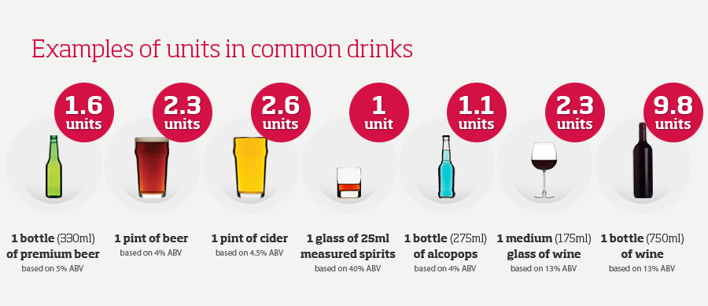

**Smoking Status**

Do you smoke Yes  No

If yes, how many cigarettes do you smoke daily: _________

If no, have you smoked in the past Yes  No

Do you use electronic cigarettes/Vape? Yes  No

Stopping smoking is not easy but it can be done, would you like further information how you can quit smoking? Yes  No

**Secondary Care**

Are you currently under hospital supervision for anything? Yes  No

If yes, please state what for and in which hospital: ____________________________________________  
Would you like to be transferred to South Tees? Yes  No

**Medications**

We recommend that you order your repeat medication via online services. If you are unable to access the internet you can bring your paper repeat prescription request into the surgery.

We require three working days to process Repeat Prescriptions.

* If you live further than 1 mile from the surgery, you are eligible to collect your medication from our Dispensary.
* If you live within a mile of the Surgery, you will need to nominate a pharmacy to collect your prescriptions from; Nominated Pharmacy: _______________________________

Please list your repeat medication or attach a copy of your repeat prescription:

_______________________________________________________

_______________________________________________________

_______________________________________________________

**Women only**: Are you;

Pregnant Yes  No

On contraception? Yes  No  If yes please state what this is; _____________________________